|  |
| --- |
|  |
| EXPERIMENT 6 |
|  |
|  |
| **Vansh Sukhija**  **12112021** |
|  |

|  |
| --- |
|  |

Ans 1(i)-

#include<stdio.h>

#include<stdlib.h>

#include<string.h>

*struct* Node{

*char* data[10];

*struct* Node *next;

};

*struct* Node *create(){

*struct* Node *first = (*struct* Node*)malloc(sizeof(*struct* Node)), *last;

    printf("Enter data: ");

    scanf("%s", &first->data);

    first->next = NULL;

    last = first;

*int* input=0;

    printf("Enter '1' to enter more data or '0' to exit: ");

    scanf("%d", &input);

    while(input==1){

*struct* Node *new = (*struct* Node *)malloc(sizeof(*struct* Node));

        fflush(stdin);

        printf("Enter data: ");

        scanf("%s", &new->data);

        new->next = NULL;

        last->next = new;

        last = new;

        printf("Enter '1' to enter more data or '0' to exit: ");

        scanf("%d", &input);

    }

    last->next = first;

    return first;

}

*void* display(*struct* Node \**ptr*){

*struct* Node *p = *ptr*;

    printf("Linked List: ");

    do{

        printf("%s ", p->data);

        p = p->next;

    }while(p!=*ptr*);

    printf("\n\n");

}

*void* insert(*struct* Node \**ptr*, *char* *pos*[], *char* *key*[]){

*struct* Node *p = *ptr*, *new = (*struct* Node *)malloc(sizeof(*struct* Node));

    strcpy(new->data, *key*);

    if(!strcmp(*ptr*->data, *pos*)){

        do{

            p = p->next;

        }while(p->next!=*ptr*);

        new->next = p->next;

        p->next = new;

    }

    else{

        do{

            p = p->next;

        }while(strcmp(p->next->data, *pos*));

        new->next = p->next;

        p->next = new;

    }

}

*void* main(){

*struct* Node *first = create();

    display(first);

    insert(first, "def", "xyz");

    display(first);

}

Output-

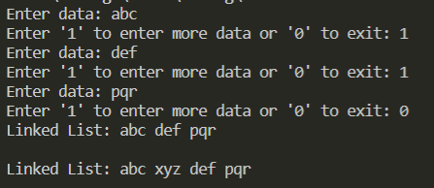

Ans 1(ii)-

#include<stdio.h>

#include<stdlib.h>

#include<string.h>

*struct* Node{

*char* data[10];

*struct* Node *next;

};

*struct* Node *create(){

*struct* Node *first = (*struct* Node*)malloc(sizeof(*struct* Node)), *last;

    printf("Enter data: ");

    scanf("%s", &first->data);

    first->next = NULL;

    last = first;

*int* input=0;

    printf("Enter '1' to enter more data or '0' to exit: ");

    scanf("%d", &input);

    while(input==1){

*struct* Node *new = (*struct* Node *)malloc(sizeof(*struct* Node));

        fflush(stdin);

        printf("Enter data: ");

        scanf("%s", &new->data);

        new->next = NULL;

        last->next = new;

        last = new;

        printf("Enter '1' to enter more data or '0' to exit: ");

        scanf("%d", &input);

    }

    last->next = first;

    return first;

}

*void* display(*struct* Node \**ptr*){

*struct* Node *p = *ptr*;

    printf("Linked List: ");

    do{

        printf("%s ", p->data);

        p = p->next;

    }while(p!=*ptr*);

    printf("\n\n");

}

*void* insert(*struct* Node \**ptr*, *char* *pos*[], *char* *key*[]){

*struct* Node *p = *ptr*, *new = (*struct* Node *)malloc(sizeof(*struct* Node));

    strcpy(new->data, *key*);

    if(!strcmp(*ptr*->data, *pos*)){

        new->next = *ptr*->next;

*ptr*->next = new;

    }

    else{

        do{

            p = p->next;

        }while(strcmp(p->data, *pos*));

        new->next = p->next;

        p->next = new;

    }

}

*void* main(){

*struct* Node *first = create();

    display(first);

    insert(first, "def", "xyz");

    display(first);

}

Output-

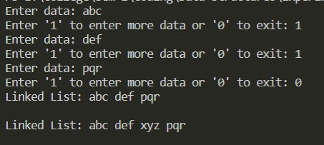

Ans 1(iii)-

#include<stdio.h>

#include<stdlib.h>

#include<string.h>

*struct* Node{

*char* data[10];

*struct* Node *next;

};

*struct* Node *create(){

*struct* Node *first = (*struct* Node*)malloc(sizeof(*struct* Node)), *last;

    printf("Enter data: ");

    scanf("%s", &first->data);

    first->next = NULL;

    last = first;

*int* input=0;

    printf("Enter '1' to enter more data or '0' to exit: ");

    scanf("%d", &input);

    while(input==1){

*struct* Node *new = (*struct* Node *)malloc(sizeof(*struct* Node));

        fflush(stdin);

        printf("Enter data: ");

        scanf("%s", &new->data);

        new->next = NULL;

        last->next = new;

        last = new;

        printf("Enter '1' to enter more data or '0' to exit: ");

        scanf("%d", &input);

    }

    last->next = first;

    return first;

}

*void* display(*struct* Node \**ptr*){

*struct* Node *p = *ptr*;

    printf("Linked List: ");

    do{

        printf("%s ", p->data);

        p = p->next;

    }while(p!=*ptr*);

    printf("\n\n");

}

*int* pos(*struct* Node \**ptr*, *char* *data*[]){

*int* count=0;

*struct* Node *p = *ptr*;

    do{

        if(!strcmp(p->data, *data*))

            return count;

        p = p->next;

        count++;

    }while(p!=*ptr*);

    return -1;

}

*void* main(){

*struct* Node *first = create();

    display(first);

    printf("Position of 'xyz' wrt to head is: %d", pos(first, "xyz"));

}

Output-

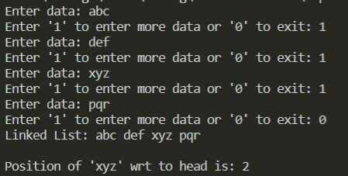

Ans 1(iv)-

#include<stdio.h>

#include<stdlib.h>

#include<string.h>

*struct* Node{

*char* data[10];

*struct* Node *next;

};

*struct* Node *create(){

*struct* Node *first = (*struct* Node*)malloc(sizeof(*struct* Node)), *last;

    printf("Enter data: ");

    scanf("%s", &first->data);

    first->next = NULL;

    last = first;

*int* input=0;

    printf("Enter '1' to enter more data or '0' to exit: ");

    scanf("%d", &input);

    while(input==1){

*struct* Node *new = (*struct* Node *)malloc(sizeof(*struct* Node));

        fflush(stdin);

        printf("Enter data: ");

        scanf("%s", &new->data);

        new->next = NULL;

        last->next = new;

        last = new;

        printf("Enter '1' to enter more data or '0' to exit: ");

        scanf("%d", &input);

    }

    last->next = first;

    return first;

}

*void* display(*struct* Node \**ptr*){

*struct* Node *p = *ptr*;

    printf("Linked List: ");

    do{

        printf("%s ", p->data);

        p = p->next;

    }while(p!=*ptr*);

    printf("\n\n");

}

*void* delete(*struct* Node \*\**ptr*, *char* *key*[]){

*struct* Node *p = \**ptr*, *q;

    while(strcmp(*key*, p->next->data) && p!=(\**ptr*)){

        p = p->next;

    }

    if(p->next == (\**ptr*)){

        p->next = (\**ptr*)->next;

        q = \**ptr*;

        (\**ptr*) = p->next;

    }

    else{

        q = p->next;

        p->next = q->next;

    }

    free(q);

}

*void* main(){

*struct* Node *first = create();

    display(first);

    delete(&first, "xyz");

    display(first);

}

Output-

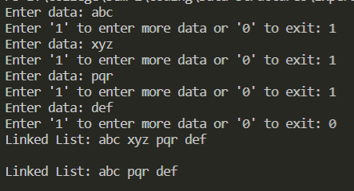

Ans 1(v)-

#include<stdio.h>

#include<stdlib.h>

#include<string.h>

*struct* Node{

*char* data[10];

*struct* Node *next;

};

*struct* Node *create(){

*struct* Node *first = (*struct* Node*)malloc(sizeof(*struct* Node)), *last;

    printf("Enter data: ");

    scanf("%s", &first->data);

    first->next = NULL;

    last = first;

*int* input=0;

    printf("Enter '1' to enter more data or '0' to exit: ");

    scanf("%d", &input);

    while(input==1){

*struct* Node *new = (*struct* Node *)malloc(sizeof(*struct* Node));

        fflush(stdin);

        printf("Enter data: ");

        scanf("%s", &new->data);

        new->next = NULL;

        last->next = new;

        last = new;

        printf("Enter '1' to enter more data or '0' to exit: ");

        scanf("%d", &input);

    }

    last->next = first;

    return first;

}

*void* display(*struct* Node \**ptr*){

*struct* Node *p = *ptr*;

    printf("Linked List: ");

    if(*ptr*!=0){

        do{

            printf("%s ", p->data);

            p = p->next;

        }while(p!=*ptr*);

    }

    printf("\n\n");

}

*void* deleteall(*struct* Node \**ptr*){

    while(*ptr*->next != *ptr*){

*struct* Node *p = *ptr*->next;

*ptr*->next = p->next;

        free(p);

    }

    free(*ptr*);

}

*void* main(){

*struct* Node *first = create();

    display(first);

    deleteall(first);

    display(first);

}

Output-

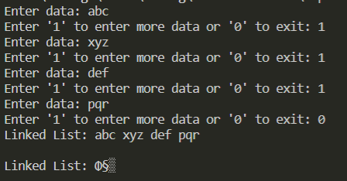

Ans 1(vi)-

#include<stdio.h>

#include<stdlib.h>

#include<string.h>

*struct* Node{

*char* data[10];

*struct* Node *next;

};

*struct* Node *create(){

*struct* Node *first = (*struct* Node*)malloc(sizeof(*struct* Node)), *last;

    printf("Enter data: ");

    scanf("%s", &first->data);

    first->next = NULL;

    last = first;

*int* input=0;

    printf("Enter '1' to enter more data or '0' to exit: ");

    scanf("%d", &input);

    while(input==1){

*struct* Node *new = (*struct* Node *)malloc(sizeof(*struct* Node));

        fflush(stdin);

        printf("Enter data: ");

        scanf("%s", &new->data);

        new->next = NULL;

        last->next = new;

        last = new;

        printf("Enter '1' to enter more data or '0' to exit: ");

        scanf("%d", &input);

    }

    last->next = first;

    return first;

}

*void* display(*struct* Node \**ptr*){

*struct* Node *p = *ptr*;

    printf("Linked List: ");

    do{

        printf("%s ", p->data);

        p = p->next;

    }while(p!=*ptr*);

    printf("\n");

}

*void* main(){

*struct* Node *first = create();

    display(first);

}

Output-

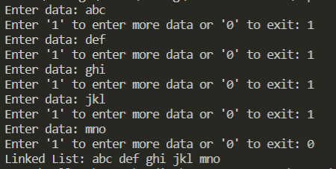

Ans 1(vii)-

#include<stdio.h>

#include<stdlib.h>

#include<string.h>

*struct* Node{

*char* data[10];

*struct* Node *next;

};

*struct* Node *create(){

*struct* Node *first = (*struct* Node*)malloc(sizeof(*struct* Node)), *last;

    printf("Enter data: ");

    scanf("%s", &first->data);

    first->next = NULL;

    last = first;

*int* input=0;

    printf("Enter '1' to enter more data or '0' to exit: ");

    scanf("%d", &input);

    while(input==1){

*struct* Node *new = (*struct* Node *)malloc(sizeof(*struct* Node));

        fflush(stdin);

        printf("Enter data: ");

        scanf("%s", &new->data);

        new->next = NULL;

        last->next = new;

        last = new;

        printf("Enter '1' to enter more data or '0' to exit: ");

        scanf("%d", &input);

    }

    last->next = first;

    return first;

}

*void* display(*struct* Node \**ptr*){

*struct* Node *p = *ptr*;

    printf("Linked List: ");

    do{

        printf("%s ", p->data);

        p = p->next;

    }while(p!=*ptr*);

    printf("\n\n");

}

*void* sorting(*struct* Node \**ptr*){

*struct* Node *q = *ptr*, *min;

*int* flag1=0;

    while(q!=*ptr* || !flag1){

*int* flag2=0;

        flag1 = 1;

        min = q;

*struct* Node *temp = q;

        while(temp!=*ptr* || !flag2){

            flag2 = 1;

            if(strcmp(temp->data, min->data) < 0)

                min = temp;

            temp = temp->next;

        }

*char* x[10];

        strcpy(x, min->data);

        strcpy(min->data, q->data);

        strcpy(q->data, x);

        q = q->next;

    }

}

*void* main(){

*struct* Node *first = create();

    display(first);

    sorting(first);

    display(first);

}

Output-

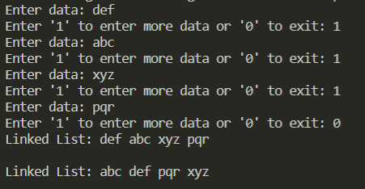

Ans 2(i)-

#include<stdio.h>

#include<stdlib.h>

#include<string.h>

*struct* Student{

*struct* Student *prev, *next;

*int* rollno, marks;

*char* name[20];

};

*struct* Student *create(){

*struct* Student *first = (*struct* Student *)malloc(sizeof(*struct* Student)), *last;

    first->prev = NULL;

    first->next = NULL;

    printf("Enter name: ");

    gets(first->name);

    printf("Enter Roll No: ");

    scanf("%d", &first->rollno);

    printf("Enter total marks: ");

    scanf("%d", &first->marks);

    last = first;

*int* input;

    printf("\nEnter '1' to enter more data or '0' to exit: ");

    scanf("%d", &input);

    while(input){

*struct* Student *new = (*struct* Student *)malloc(sizeof(*struct* Student));

        new->next = NULL;

        new->prev = last;

        last->next = new;

        last = new;

        fflush(stdin);

        printf("Enter name: ");

        gets(new->name);

        printf("Enter Roll No: ");

        scanf("%d", &new->rollno);

        printf("Enter total marks: ");

        scanf("%d", &new->marks);

        printf("\nEnter '1' to enter more data or '0' to exit: ");

        scanf("%d", &input);

    }

    return first;

}

*void* display(*struct* Student \**ptr*){

    printf("---------------Displaying Data---------------\n");

    while(*ptr*!=0){

        puts(*ptr*->name);

        printf("%d\n", *ptr*->rollno);

        printf("%d\n\n", *ptr*->marks);

*ptr* = *ptr*->next;

    }

}

*void* insert(*struct* Student \*\**ptr*, *int* *key*){

*struct* Student *new = (*struct* Student *)malloc(sizeof(*struct* Student));

    fflush(stdin);

    printf("Enter name: ");

    gets(new->name);

    printf("Enter Roll No: ");

    scanf("%d", &new->rollno);

    printf("Enter total marks: ");

    scanf("%d", &new->marks);

    if(*key* == (\**ptr*)->rollno){

        new->next = \**ptr*;

        new->prev = NULL;

        (\**ptr*)->prev = new;

        \**ptr* = new;

    }

    else{

*struct* Student *p = \**ptr*;

        while(p->next!=0 && p->next->rollno != *key*){

            p = p->next;

        }

        new->prev = p;

        new->next = p->next;

        p->next->prev = new;

        p->next = new;

    }

}

*void* main(){

*struct* Student *first;

    first = create();

    display(first);

    insert(&first, 12112021);

    display(first);

}

Output-

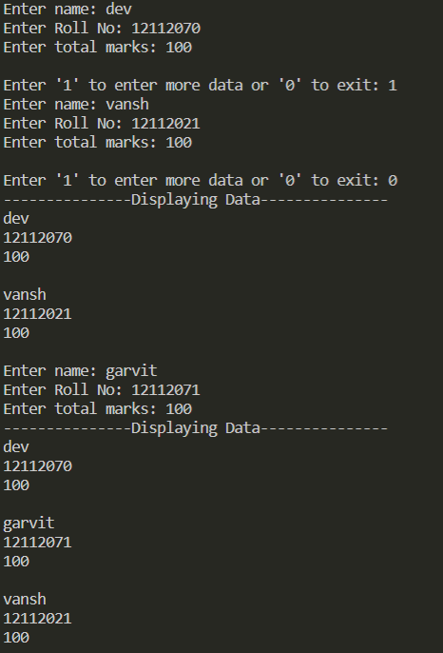

Ans 2(ii)-

#include<stdio.h>

#include<stdlib.h>

#include<string.h>

*struct* Student{

*struct* Student *prev, *next;

*int* rollno, marks;

*char* name[20];

};

*struct* Student *create(){

*struct* Student *first = (*struct* Student *)malloc(sizeof(*struct* Student)), *last;

    first->prev = NULL;

    first->next = NULL;

    printf("Enter name: ");

    gets(first->name);

    printf("Enter Roll No: ");

    scanf("%d", &first->rollno);

    printf("Enter total marks: ");

    scanf("%d", &first->marks);

    last = first;

*int* input;

    printf("\nEnter '1' to enter more data or '0' to exit: ");

    scanf("%d", &input);

    while(input){

*struct* Student *new = (*struct* Student *)malloc(sizeof(*struct* Student));

        new->next = NULL;

        new->prev = last;

        last->next = new;

        last = new;

        fflush(stdin);

        printf("Enter name: ");

        gets(new->name);

        printf("Enter Roll No: ");

        scanf("%d", &new->rollno);

        printf("Enter total marks: ");

        scanf("%d", &new->marks);

        printf("\nEnter '1' to enter more data or '0' to exit: ");

        scanf("%d", &input);

    }

    return first;

}

*void* display(*struct* Student \**ptr*){

    printf("---------------Displaying Data---------------\n");

    while(*ptr*!=0){

        puts(*ptr*->name);

        printf("%d\n", *ptr*->rollno);

        printf("%d\n\n", *ptr*->marks);

*ptr* = *ptr*->next;

    }

}

*void* insert(*struct* Student \**p*, *int* *key*){

*struct* Student *new = (*struct* Student *)malloc(sizeof(*struct* Student));

    fflush(stdin);

    printf("Enter name: ");

    gets(new->name);

    printf("Enter Roll No: ");

    scanf("%d", &new->rollno);

    printf("Enter total marks: ");

    scanf("%d", &new->marks);

    while(*p*->next!=0 && *p*->rollno != *key*){

*p* = *p*->next;

    }

    new->prev = *p*;

    new->next = *p*->next;

*p*->next->prev = new;

*p*->next = new;

}

*void* main(){

*struct* Student *first;

    first = create();

    display(first);

    insert(first, 12112021);

    display(first);

}

Output-

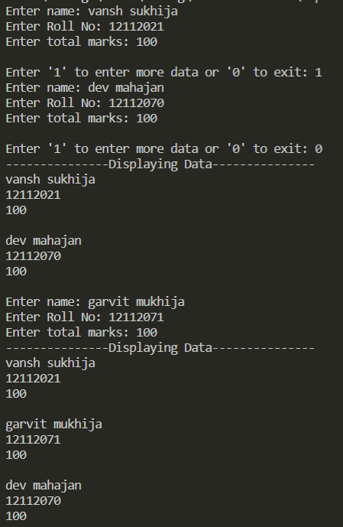

Ans 2(iii)-

#include<stdio.h>

#include<stdlib.h>

#include<string.h>

*struct* Student{

*struct* Student *prev, *next;

*int* rollno, marks;

*char* name[20];

};

*struct* Student *create(){

*struct* Student *first = (*struct* Student *)malloc(sizeof(*struct* Student)), *last;

    first->prev = NULL;

    first->next = NULL;

    printf("Enter name: ");

    gets(first->name);

    printf("Enter Roll No: ");

    scanf("%d", &first->rollno);

    printf("Enter total marks: ");

    scanf("%d", &first->marks);

    last = first;

*int* input;

    printf("\nEnter '1' to enter more data or '0' to exit: ");

    scanf("%d", &input);

    while(input){

*struct* Student *new = (*struct* Student *)malloc(sizeof(*struct* Student));

        new->next = NULL;

        new->prev = last;

        last->next = new;

        last = new;

        fflush(stdin);

        printf("Enter name: ");

        gets(new->name);

        printf("Enter Roll No: ");

        scanf("%d", &new->rollno);

        printf("Enter total marks: ");

        scanf("%d", &new->marks);

        printf("\nEnter '1' to enter more data or '0' to exit: ");

        scanf("%d", &input);

    }

    return first;

}

*void* display(*struct* Student \**ptr*){

    printf("---------------Displaying Data---------------\n");

    while(*ptr*!=0){

        puts(*ptr*->name);

        printf("%d\n", *ptr*->rollno);

        printf("%d\n\n", *ptr*->marks);

*ptr* = *ptr*->next;

    }

}

*void* insert(*struct* Student \*\**ptr*, *int* *pos*){

*struct* Student *new = (*struct* Student *)malloc(sizeof(*struct* Student)), *p = (\**ptr*);

    fflush(stdin);

    printf("Enter name: ");

    gets(new->name);

    printf("Enter Roll No: ");

    scanf("%d", &new->rollno);

    printf("Enter total marks: ");

    scanf("%d", &new->marks);

    if((\**ptr*)==NULL){

        (\**ptr*) = new;

        new->next = NULL;

        new->prev = NULL;

    }

    else if(*pos*==0){

        new->next = (\**ptr*);

        (\**ptr*)->prev = new;

        new->prev = NULL;

        (\**ptr*) = new;

    }

    else{

        for(*int* i=0; i<*pos*-1; i++){

            p = p->next;

        }

        new->next = p->next;

        new->prev = p;

        p->next->prev = new;

        p->next = new;

    }

}

*void* main(){

*struct* Student *first;

    first = create();

    display(first);

    insert(&first, 1);

    display(first);

}

Output-

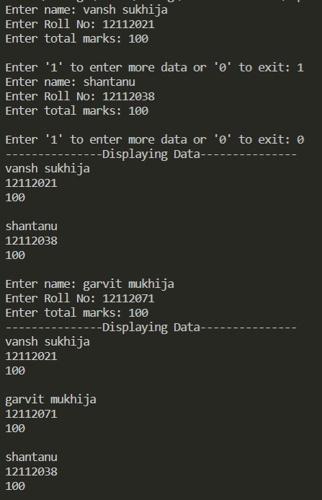

Ans 2(iv)-

#include<stdio.h>

#include<stdlib.h>

#include<string.h>

*struct* Student{

*struct* Student *prev, *next;

*int* rollno, marks;

*char* name[20];

};

*struct* Student *create(){

*struct* Student *first = (*struct* Student *)malloc(sizeof(*struct* Student)), *last;

    first->prev = NULL;

    first->next = NULL;

    printf("Enter name: ");

    gets(first->name);

    printf("Enter Roll No: ");

    scanf("%d", &first->rollno);

    printf("Enter total marks: ");

    scanf("%d", &first->marks);

    last = first;

*int* input;

    printf("\nEnter '1' to enter more data or '0' to exit: ");

    scanf("%d", &input);

    while(input){

*struct* Student *new = (*struct* Student *)malloc(sizeof(*struct* Student));

        new->next = NULL;

        new->prev = last;

        last->next = new;

        last = new;

        fflush(stdin);

        printf("Enter name: ");

        gets(new->name);

        printf("Enter Roll No: ");

        scanf("%d", &new->rollno);

        printf("Enter total marks: ");

        scanf("%d", &new->marks);

        printf("\nEnter '1' to enter more data or '0' to exit: ");

        scanf("%d", &input);

    }

    return first;

}

*void* display(*struct* Student \**ptr*){

    printf("---------------Displaying Data---------------\n");

    while(*ptr*!=0){

        puts(*ptr*->name);

        printf("%d\n", *ptr*->rollno);

        printf("%d\n\n", *ptr*->marks);

*ptr* = *ptr*->next;

    }

}

*int* pos(*struct* Student \**ptr*, *int* *key*){

*int* count=1;

    while(*ptr*!=0){

        if(*ptr*->rollno == *key*)

            return count;

*ptr* = *ptr*->next;

        count++;

    }

    return -1;

}

*void* main(){

*struct* Student *first;

    first = create();

    display(first);

    printf("Position of Roll no. %d wrt %d is: %d", 12112021, first->rollno, pos(first, 12112021));

}

Output-

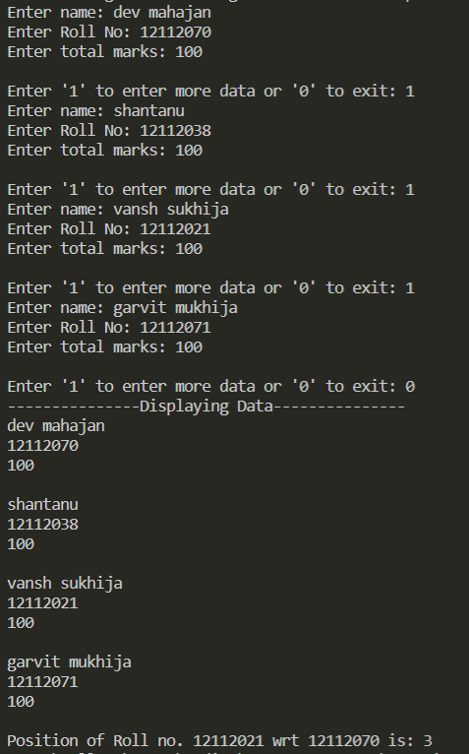

Ans 2(v)-

#include<stdio.h>

#include<stdlib.h>

#include<string.h>

*struct* Student{

*struct* Student *prev, *next;

*int* rollno, marks;

*char* name[20];

};

*struct* Student *create(){

*struct* Student *first = (*struct* Student *)malloc(sizeof(*struct* Student)), *last;

    first->prev = NULL;

    first->next = NULL;

    printf("Enter name: ");

    gets(first->name);

    printf("Enter Roll No: ");

    scanf("%d", &first->rollno);

    printf("Enter total marks: ");

    scanf("%d", &first->marks);

    last = first;

*int* input;

    printf("\nEnter '1' to enter more data or '0' to exit: ");

    scanf("%d", &input);

    while(input){

*struct* Student *new = (*struct* Student *)malloc(sizeof(*struct* Student));

        new->next = NULL;

        new->prev = last;

        last->next = new;

        last = new;

        fflush(stdin);

        printf("Enter name: ");

        gets(new->name);

        printf("Enter Roll No: ");

        scanf("%d", &new->rollno);

        printf("Enter total marks: ");

        scanf("%d", &new->marks);

        printf("\nEnter '1' to enter more data or '0' to exit: ");

        scanf("%d", &input);

    }

    return first;

}

*void* display(*struct* Student \**ptr*){

    printf("---------------Displaying Data---------------\n");

    while(*ptr*!=0){

        puts(*ptr*->name);

        printf("%d\n", *ptr*->rollno);

        printf("%d\n\n", *ptr*->marks);

*ptr* = *ptr*->next;

    }

}

*void* delete(*struct* Student \*\**ptr*, *int* *key*){

*struct* Student *p = \**ptr*;

    if((\**ptr*)->rollno == *key*){

        (\**ptr*) = p->next;

        (\**ptr*)->prev = NULL;

    }

    else{

        while(p->rollno!=*key*){

            p = p->next;

        }

        if(p->next){

            p->prev->next = p->next;

            p->next->prev = p->prev;

        }

        else

            p->prev->next = p->next;

    }

    free(p);

}

*void* main(){

*struct* Student *first;

    first = create();

    display(first);

    delete(&first, 12112021);

    display(first);

}

Output-

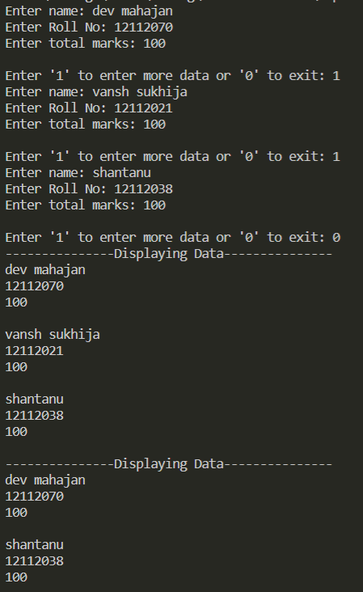

Ans 2(vi)-

#include<stdio.h>

#include<stdlib.h>

#include<string.h>

*struct* Student{

*struct* Student *prev, *next;

*int* rollno, marks;

*char* name[20];

};

*struct* Student *create(){

*struct* Student *first = (*struct* Student *)malloc(sizeof(*struct* Student)), *last;

    first->prev = NULL;

    first->next = NULL;

    printf("Enter name: ");

    gets(first->name);

    printf("Enter Roll No: ");

    scanf("%d", &first->rollno);

    printf("Enter total marks: ");

    scanf("%d", &first->marks);

    last = first;

*int* input;

    printf("\nEnter '1' to enter more data or '0' to exit: ");

    scanf("%d", &input);

    while(input){

*struct* Student *new = (*struct* Student *)malloc(sizeof(*struct* Student));

        new->next = NULL;

        new->prev = last;

        last->next = new;

        last = new;

        fflush(stdin);

        printf("Enter name: ");

        gets(new->name);

        printf("Enter Roll No: ");

        scanf("%d", &new->rollno);

        printf("Enter total marks: ");

        scanf("%d", &new->marks);

        printf("\nEnter '1' to enter more data or '0' to exit: ");

        scanf("%d", &input);

    }

    return first;

}

*void* display(*struct* Student \**ptr*){

    printf("---------------Displaying Data---------------\n");

    while(*ptr*!=0){

        puts(*ptr*->name);

        printf("%d\n", *ptr*->rollno);

        printf("%d\n\n", *ptr*->marks);

*ptr* = *ptr*->next;

    }

}

*void* deleteall(*struct* Student \*\**ptr*){

    while((\**ptr*)->next!=0){

*struct* Student *p = \**ptr*;

        \**ptr* = p->next;

        (\**ptr*)->prev = NULL;

        free(p);

    }

    free((\**ptr*));

}

*void* main(){

*struct* Student *first;

    first = create();

    display(first);

    deleteall(&first);

    display(first);

}

Output-

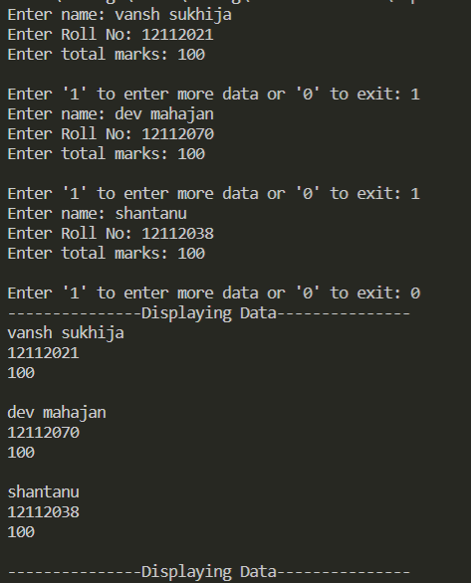

Ans 2(vii)-

#include<stdio.h>

#include<stdlib.h>

#include<string.h>

*struct* Student{

*struct* Student *prev, *next;

*int* rollno, marks;

*char* name[20];

};

*struct* Student *create(*struct* Student \*\**last*){

*struct* Student *first = (*struct* Student *)malloc(sizeof(*struct* Student));

    first->prev = NULL;

    first->next = NULL;

    printf("Enter name: ");

    gets(first->name);

    printf("Enter Roll No: ");

    scanf("%d", &first->rollno);

    printf("Enter total marks: ");

    scanf("%d", &first->marks);

    (\**last*) = first;

*int* input;

    printf("\nEnter '1' to enter more data or '0' to exit: ");

    scanf("%d", &input);

    while(input){

*struct* Student *new = (*struct* Student *)malloc(sizeof(*struct* Student));

        new->next = NULL;

        new->prev = (\**last*);

        (\**last*)->next = new;

        (\**last*) = new;

        fflush(stdin);

        printf("Enter name: ");

        gets(new->name);

        printf("Enter Roll No: ");

        scanf("%d", &new->rollno);

        printf("Enter total marks: ");

        scanf("%d", &new->marks);

        printf("\nEnter '1' to enter more data or '0' to exit: ");

        scanf("%d", &input);

    }

    return first;

}

*void* display(*struct* Student \**ptr*){

    printf("---------------Displaying Data---------------\n");

    if(!*ptr*->prev){

        while(*ptr*!=0){

            puts(*ptr*->name);

            printf("%d\n", *ptr*->rollno);

            printf("%d\n\n", *ptr*->marks);

*ptr* = *ptr*->next;

        }

    }

    else{

        while(*ptr*!=0){

            puts(*ptr*->name);

            printf("%d\n", *ptr*->rollno);

            printf("%d\n\n", *ptr*->marks);

*ptr* = *ptr*->prev;

        }

    }

}

*void* main(){

*struct* Student *first, *last;

    first = create(&last);

    display(first);

}

Output-

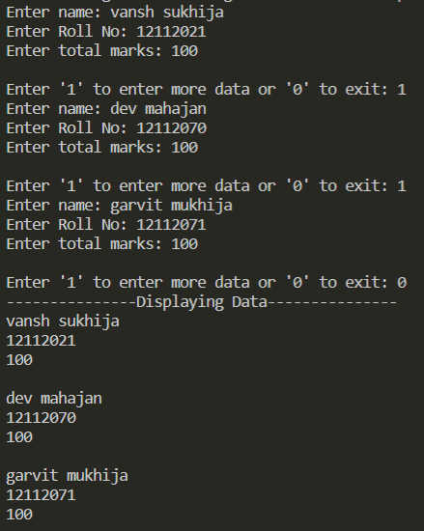

Ans 2(viii)-

#include<stdio.h>

#include<stdlib.h>

#include<string.h>

*struct* Student{

*struct* Student *prev, *next;

*int* rollno, marks;

*char* name[20];

};

*struct* Student *create(*struct* Student \*\**last*){

*struct* Student *first = (*struct* Student *)malloc(sizeof(*struct* Student));

    first->prev = NULL;

    first->next = NULL;

    printf("Enter name: ");

    gets(first->name);

    printf("Enter Roll No: ");

    scanf("%d", &first->rollno);

    printf("Enter total marks: ");

    scanf("%d", &first->marks);

    (\**last*) = first;

*int* input;

    printf("\nEnter '1' to enter more data or '0' to exit: ");

    scanf("%d", &input);

    while(input){

*struct* Student *new = (*struct* Student *)malloc(sizeof(*struct* Student));

        new->next = NULL;

        new->prev = (\**last*);

        (\**last*)->next = new;

        (\**last*) = new;

        fflush(stdin);

        printf("Enter name: ");

        gets(new->name);

        printf("Enter Roll No: ");

        scanf("%d", &new->rollno);

        printf("Enter total marks: ");

        scanf("%d", &new->marks);

        printf("\nEnter '1' to enter more data or '0' to exit: ");

        scanf("%d", &input);

    }

    return first;

}

*void* display(*struct* Student \**ptr*){

    printf("---------------Displaying Data---------------\n");

    if(!*ptr*->prev){

        while(*ptr*!=0){

            puts(*ptr*->name);

            printf("%d\n", *ptr*->rollno);

            printf("%d\n\n", *ptr*->marks);

*ptr* = *ptr*->next;

        }

    }

    else{

        while(*ptr*!=0){

            puts(*ptr*->name);

            printf("%d\n", *ptr*->rollno);

            printf("%d\n\n", *ptr*->marks);

*ptr* = *ptr*->prev;

        }

    }

}

*void* main(){

*struct* Student *first, *last;

    first = create(&last);

    display(last);

}

Output-

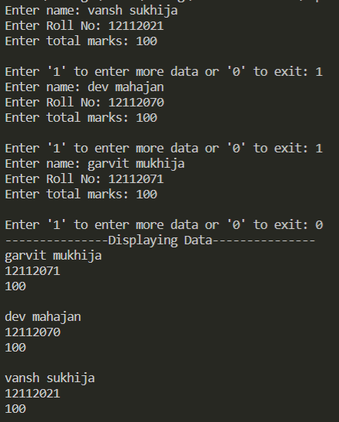

Ans 2(ix)-

#include<stdio.h>

#include<stdlib.h>

#include<string.h>

*struct* Student{

*struct* Student *prev, *next;

*int* rollno, marks;

*char* name[20];

};

*struct* Student *create(){

*struct* Student *first = (*struct* Student *)malloc(sizeof(*struct* Student)), *last;

    first->prev = NULL;

    first->next = NULL;

    printf("Enter name: ");

    gets(first->name);

    printf("Enter Roll No: ");

    scanf("%d", &first->rollno);

    printf("Enter total marks: ");

    scanf("%d", &first->marks);

    last = first;

*int* input;

    printf("\nEnter '1' to enter more data or '0' to exit: ");

    scanf("%d", &input);

    while(input){

*struct* Student *new = (*struct* Student *)malloc(sizeof(*struct* Student));

        new->next = NULL;

        new->prev = last;

        last->next = new;

        last = new;

        fflush(stdin);

        printf("Enter name: ");

        gets(new->name);

        printf("Enter Roll No: ");

        scanf("%d", &new->rollno);

        printf("Enter total marks: ");

        scanf("%d", &new->marks);

        printf("\nEnter '1' to enter more data or '0' to exit: ");

        scanf("%d", &input);

    }

    return first;

}

*void* display(*struct* Student \**ptr*){

    printf("---------------Displaying Data---------------\n");

    while(*ptr*!=0){

        puts(*ptr*->name);

        printf("%d\n", *ptr*->rollno);

        printf("%d\n\n", *ptr*->marks);

*ptr* = *ptr*->next;

    }

}

*void* sorting(*struct* Student \**ptr*){

*struct* Student *q = *ptr*, *min;

    while(q!=0){

        min = q;

*struct* Student *temp = q;

        while(temp!=0){

            if(temp->rollno < min->rollno)

                min = temp;

            temp = temp->next;

        }

        // Data swapping ahead of this line

*int* num;

        num = q->rollno;

        q->rollno = min->rollno;

        min->rollno = num;

        num = q->marks;

        q->marks = min->marks;

        min->marks = num;

*char* str[20];

        strcpy(str, q->name);

        strcpy(q->name, min->name);

        strcpy(min->name, str);

        q = q->next;

    }

}

*void* main(){

*struct* Student *first;

    first = create();

    display(first);

    sorting(first);

    display(first);

}

Output-

